Hla Myint Myat /185923216

This Assignment 3 provided me with a hands-on opportunity to delve deeper into server-side development and deployment processes. As someone relatively new to backend development, I found the experience both challenging and rewarding.

One aspect of the assignment that I particularly enjoyed was working with Node.js and Express.js to create a RESTful API for managing LEGO set data. Building endpoints to handle CRUD operations allowed me to grasp the fundamentals of routing, middleware, and error handling in Express. Additionally, integrating promises for asynchronous operations enhanced my understanding of JavaScript's event-driven nature.

Deploying the application was a significant milestone in the assignment. Deploying my application was a journey filled with unexpected challenges. Despite diligently uploading my files to GitHub, I faced roadblocks along the way. I learned the importance of careful preparation and attention to detail, from configuring environment variables to troubleshooting compatibility issues. Even when things didn't go as planned, I remained determined to overcome the obstacles. I took guidance from documentation and online resources and I tried for both cyclic and nullify to deploy but it was not successful.  
  
This screenshot is for Cyclic because I tried to deploy my other project while I couldn’t deploy this Lego sets and for nullify I was getting error like this page is not found and kept loading for a long time. I tried following YouTube tutorial but the outputs were not same.

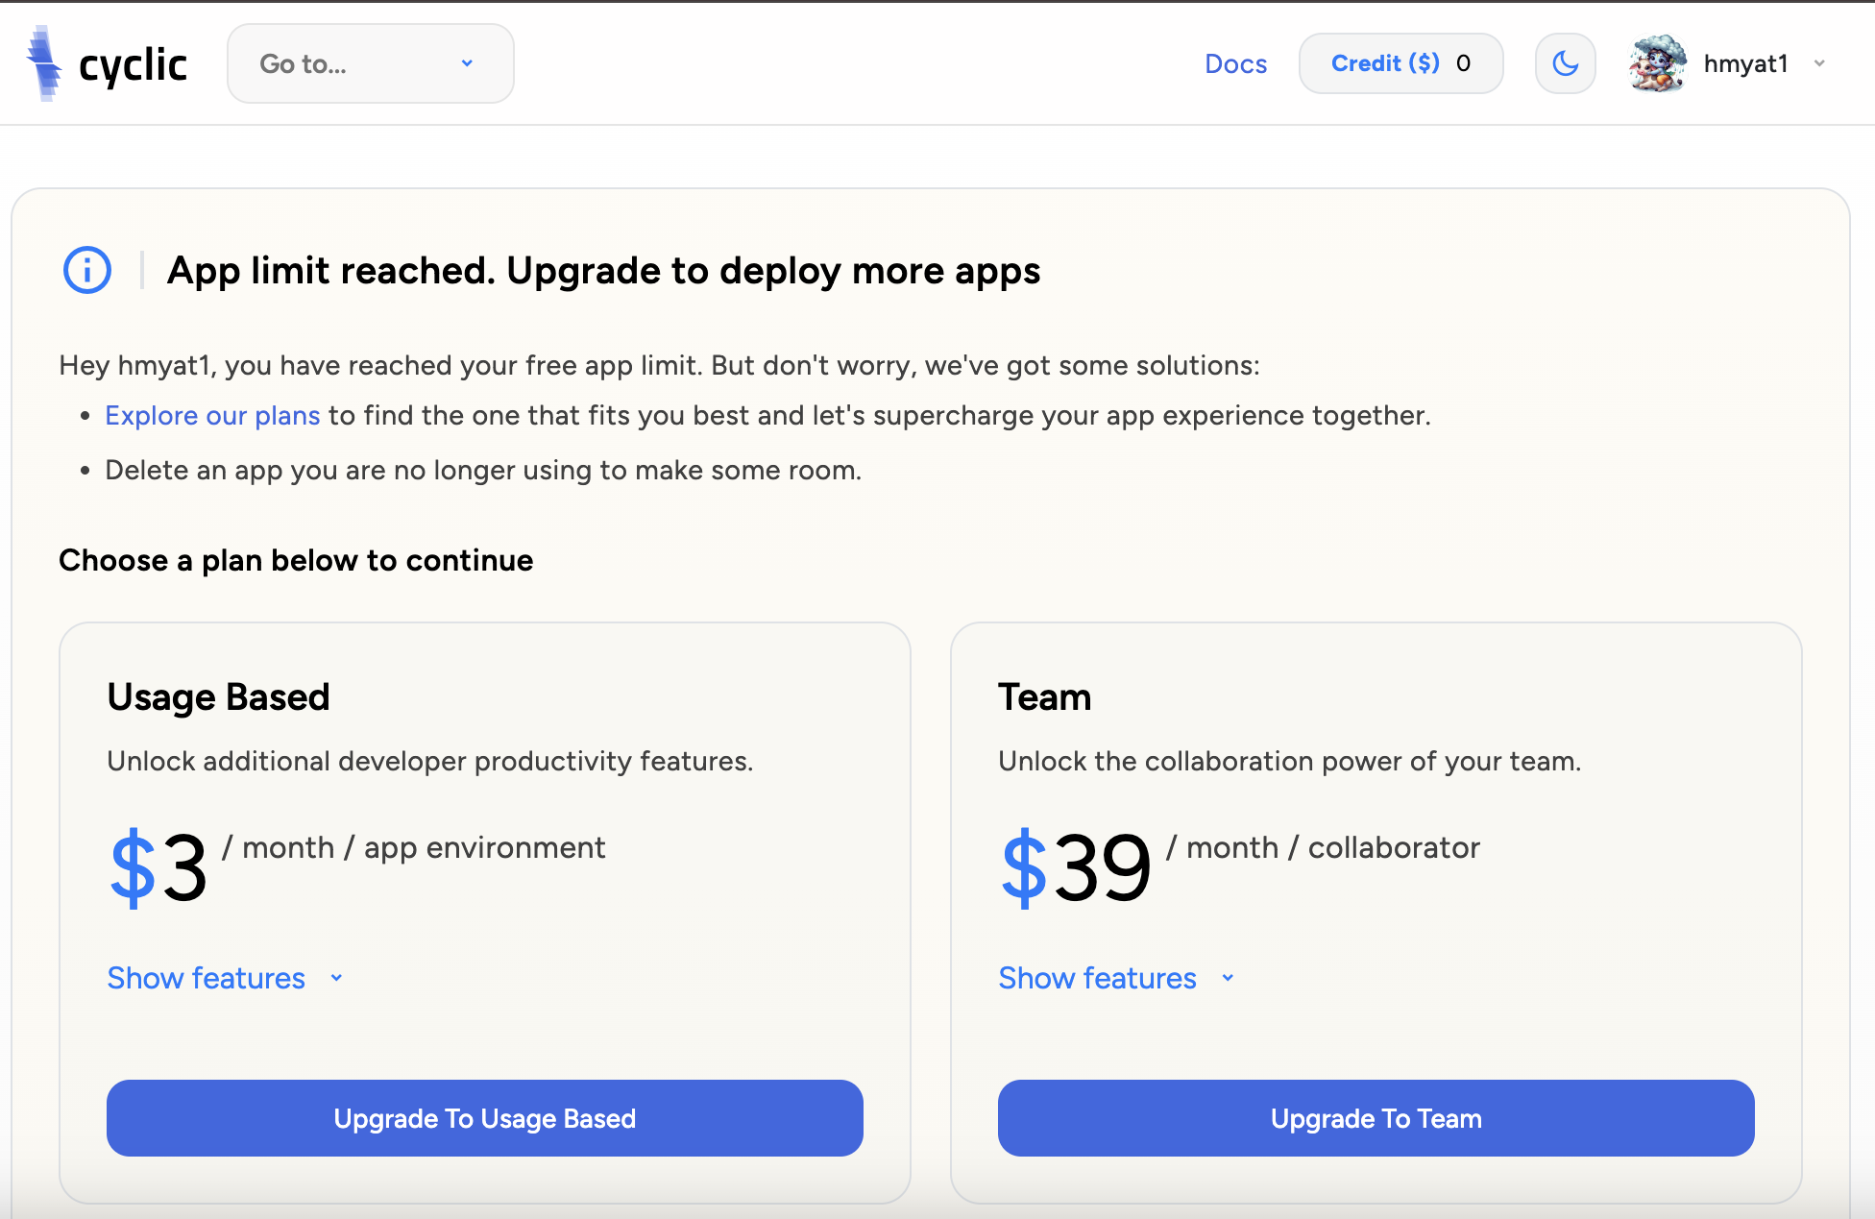

Although the deployment was not successful, I am determined to learn from these setbacks and apply my newfound knowledge in future projects. Moving forward, I am committed to refining my skills and overcoming any obstacles that come my way in my journey as a web developer.  
  
Here’s my Github Link  
<https://github.com/hmyat1/LegoSets> I made this repo public.